What is DNS? (Domain Name System)

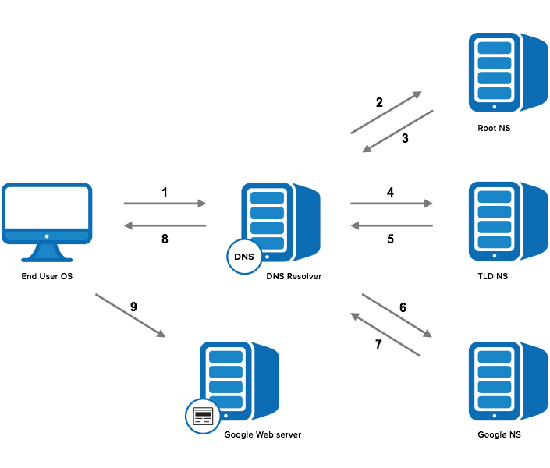
AI Generated Image
- It is a global naming system that converts human-friendly domain names into IP addresses.
- Example: When you type www.google.com, DNS translates it to an IP like 142.250.190.78 so your computer can find the correct server.
- It works in a hierarchical manner involving several servers:

1. Resolver – The local DNS server your computer asks first.
2. Root Server – Directs the query to the correct Top-Level Domain (like .com, .org).
3. TLD Server – Points to the domain’s Authoritative Name Server.
4. Authoritative Server – Returns the actual IP address of the domain.

Attack Vectors & Solutions

Attack Vector 1: Cache Poisoning / DNS Spoofing
- What it is: An attacker injects false information into a DNS resolver’s cache so that when users ask for a domain, they get a wrong IP often one the attacker controls.
- Why it matters: Users or devices trust the DNS result and may go to a malicious site thinking it’s the legitimate one (phishing, malware drop, credential theft).
- Solution: Enable and use DNSSEC (Domain Name System Security Extensions) so that DNS responses are cryptographically signed and cannot be forged easily. It also has downside it is not widely deployed and it can increase response size of DNS.
Attack Vector 2: DNS Amplification (Reflection) Attack
- What it is: An attacker sends small DNS queries to open DNS servers, spoofing the victim’s IP address. The DNS servers respond with much larger responses sent to the victim, overwhelming them.
- Why it matters: It’s a cheap but powerful form of DDoS (denial-of-service), can disrupt services or infrastructure.
- Solution: Configure the DNS servers so they are not open resolvers (i.e., they don’t answer arbitrary queries from any source) and apply rate limiting on responses.

Notable loopholes & attacks

- SIGRed (CVE-2020-1350) – Windows DNS Server Remote Code Execution
- What happened: A critical bug in Microsoft’s DNS server software allowed an unauthenticated attacker to send specially crafted DNS requests and gain execution of malicious code on the DNS server.
- Why it’s a loophole: The DNS software trusted incoming DNS requests without sufficient validation or protections. Because DNS servers often run in highly-trusted parts of networks, compromise means high risk.
- Impact: An attacker could gain full control of the DNS service (and potentially domain controllers in Windows environments)
- Take-away: Even fundamental infrastructure like DNS servers can have deep vulnerabilities; patching and protecting DNS software matters.

- 2016 Dyn DDoS attack – DNS infrastructure targeted by IoT botnet
- What happened: On October 21 2016, the DNS provider Dyn was hit by massive distributed-denial-of-service (DDoS) attacks using the Mirai botnet. Many major websites became unavailable.
- Why it’s a loophole: Attackers used numerous compromised IoT devices (with weak security) to flood DNS infrastructure, exploiting open resolvers and the fact that DNS underlies enormous online service ecosystems.
- Impact: Massive disruption of web services; highlighted how DNS and its infrastructure can serve as a lever for large-scale attacks.
- Take-away: DNS infrastructure resilience (redundancy, filtering, mitigation) and reducing exposure of open resolvers are key for security

Using DNS with VPN
- Set up the middle-device (the Raspberry Pi or any controller) to connect to the target network via a VPN tunnel.
- All traffic from the Pi goes through the VPN so it’s secure and isolated.
- The VPN ensures the Pi’s network traffic (including DNS queries) is hidden from outsiders
- Within that tunnel, your software on the Pi can perform DNS lookups/resolutions for devices in the target network:
- Forward lookups (device name to IP)
- Reverse lookups (IP to device name)
- Also check for unexpected DNS servers, open resolvers, or mismatches in hostname to and from IP.
- Because we’re using the VPN, any DNS traffic your Pi generates is encrypted and routed through the secure tunnel, reducing risk of interception or DNS leaks.

Resources

- https://en.wikipedia.org/wiki/SIGRed?utm_
- https://research.checkpoint.com/2020/resolving-your-way-into-domain-admin-exploiting-a-17-year-old-bug-in-windows-dns-servers/
- https://en.wikipedia.org/wiki/DDoS_attacks_on_Dyn?utm_
- https://www.theguardian.com/technology/2016/oct/26/ddos-attack-dyn-mirai-botnet?utm_
- https://github.com/Pratheek19014/OT_Security/blob/main/LiteratureStudyGroup/Group_4/Literature/background_research_dns_related.pdf
- https://github.com/Pratheek19014/OT_Security/blob/main/LiteratureStudyGroup/Group_4/Literature/A_survey_of_domain_name_system_vulnerabilities_and.pdf

